User Testing

Semester 6 – Advanced Media

Group 5 – Uplifting Union

1-6-2023

Inhoud

Introduction 4

Research question 4

Goal and Approach 4

User testing 5

Introduction for testing 5

Screen 1 6

On this screen, what immediately draws your attention? 6

Would you look at the screen if it was present at your work? 6

On a scale from 1-10, how would you rate the design and layout of this screen? 6

Do you feel that the content on this screen fosters a sense of recognition?" 6

On a scale from 1-10, how much do you think the content on this screen promotes a sense of recognition and appreciation? 6

If you could change anything for this screen, what would you change? 6

Screen 2 7

On this screen, what immediately draws your attention? 7

Would you look at the screen if it was present at your work? 7

On a scale from 1-10, how would you rate the design and layout of this screen? 7

On a scale from 1-10, how much do you think the content on this screen promotes a sense of recognition and appreciation? 7

If you could change anything for this screen, what would you change? 7

Screen 3 8

On this screen, what immediately draws your attention? 8

Would you look at the screen if it was present at your work? 8

On a scale from 1-10, how would you rate the design and layout of this screen? 8

On a scale from 1-10, how much do you think the content on this screen promotes a sense of recognition and appreciation? 8

If you could change anything for this screen, what would you change? 8

Screen 4 9

On screen 1, what immediately draws your attention? 9

On screen 2, what immediately draws your attention? 9

Would you look at these screens if it was present at your work? 9

On a scale from 1-10, how would you rate the design and layout of these screen 1? 9

On a scale from 1-10, how would you rate the design and layout of these screen 2? 9

On a scale from 1-10, how much do you think the content on screen 1 promotes a sense of recognition and appreciation? 10

On a scale from 1-10, how much do you think the content on screen 2 promotes a sense of recognition and appreciation? 10

If you could change anything for these screen 1, what would you change? 10

If you could change anything for these screen 2, what would you change? 10

Screen 5 11

On this screen, what immediately draws your attention? 11

Would you look at the screen if it was present at your work? 11

On a scale from 1-10, how would you rate the design and layout of this screen? 11

On a scale from 1-10, how much do you think the content on this screen promotes a sense of recognition and appreciation? 11

If you could change anything for this screen, what would you change? 11

General feedback 12

Do you have any additional feedback or suggestions related to the screens or the overall testing experience? 12

Based on your overall experience with the screens, what other types of content or features do you think could further enhance recognition and engagement at SIMAC? 12

Conclusion 13

# Introduction

In this file we are going to be testing the designs we made for the project for SIMAC. We have made a number of designs for the narrowcasting project, and have filtered the most fitting ones based on our style research and Simac's brand style guide. However, in order to verify the legitimacy of these choices, we are going to test the screens with users.

# Research question

Does the narrowcasting design help to stimulate recognition in Simac's workforce?

# Goal and Approach

Firstly, we want to A/B test some of the designs we made. Currently, we chose the what we thought would be the best design screens, we want to verify this with users.

Secondly, we want to test if the screens do work with our goal in mind. This goal is stimulating recognition in SIMAC’s workforce, thus, do these screens stimulate recognition in SIMAC’s workforce?

We want to measure and improve aspects of the screens, such as the visual design, content placement, and other relevant factors.

# User testing

## Introduction for testing

Welcome to our user test! We would like to express our sincere gratitude for your participation in this important initiative. Your valuable feedback will greatly contribute to our project for SIMAC.

Our project revolves around addressing the research question: "How can SIMAC effectively stimulate recognition within its workforce?"

To achieve this, we have developed a solution that involves implementing narrowcasting. This entails strategically placing screens throughout SIMAC's office, displaying relevant information and data about different departments. Our aim is to create content on these screens that fosters recognition, such as expressing gratitude towards long-standing employees at SIMAC.

Throughout this user test, we kindly request your insights and opinions on the effectiveness and impact of the displayed content. Your feedback will be instrumental in refining our approach and ensuring its successful implementation within SIMAC.

Once again, we sincerely appreciate your participation and look forward to your valuable input during this user test.

## Screen 1

### On this screen, what immediately draws your attention?

The images of the people, and then the title. The middle picture is the one that caught the attention first due to being centered

### Would you look at the screen if it was present at your work?

Yes, if it’s about other students like myself

### On a scale from 1-10, how would you rate the design and layout of this screen?

7.5, would make the images of the people stick out more. Theres a lot of text to the images, so I wouldn’t read all of it.

### Do you feel that the content on this screen fosters a sense of recognition?"

Yes, it’s like a slideshow of the people so it does give sense of achievements of the people

### On a scale from 1-10, how much do you think the content on this screen promotes a sense of recognition and appreciation? If you could change anything for this screen, what would you change?

7.5, Recognition part is okay, but for appreciation part I want to see some throphies or highlight achievements of what they did (in a more graphical way). Whats the cool thing about it?

## Screen 2

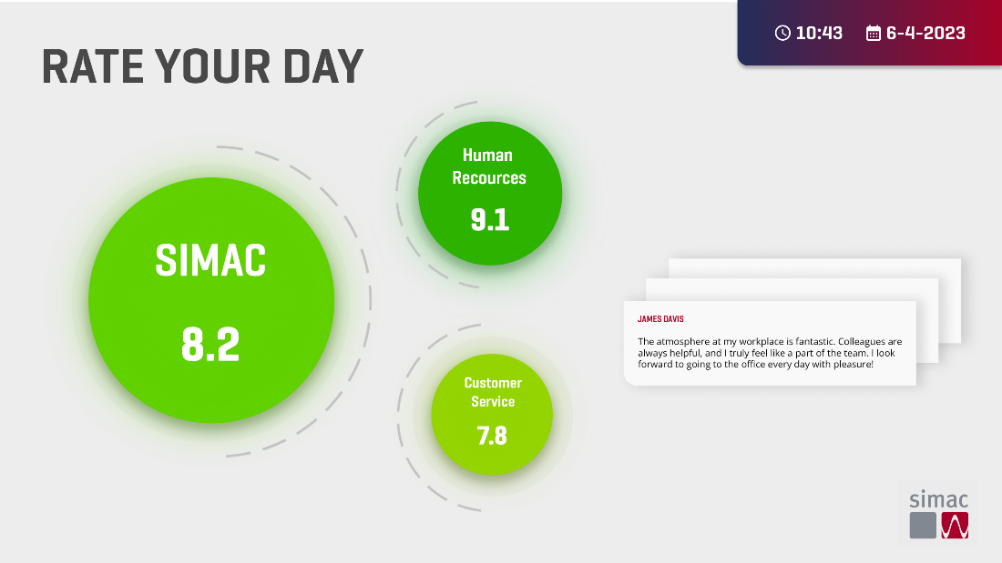

### On this screen, what immediately draws your attention?

The green circles, and the comments that are a lot of text

### Would you look at the screen if it was present at your work?

Definitely, it looks like it’s giving statistics. The circles are also green and big so it draws a lot of attention

### On a scale from 1-10, how would you rate the design and layout of this screen?

8, text of the comments is too small, and I need to really focus to recognize it as a comment

I like how minimalist it is, very clean and clear that it is supposed to be statistics. Also good that you can read other people opinions so it feels that they matter

### On a scale from 1-10, how much do you think the content on this screen promotes a sense of recognition and appreciation?

9, its straightforward and you can see how SIMAC is doing.

### If you could change anything for this screen, what would you change?

Some sort of indication that it displays information dynamically

## Screen 3

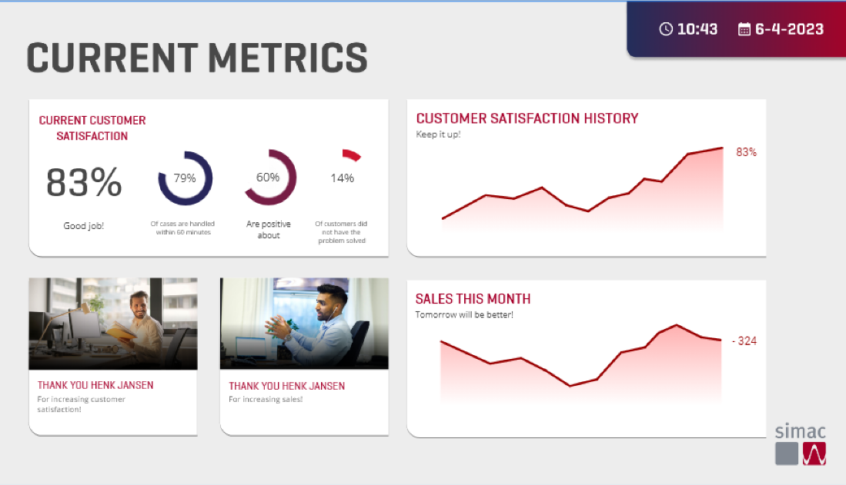

### On this screen, what immediately draws your attention?

The title and the circle progress bars.

### Would you look at the screen if it was present at your work?

It’s too much. I would only look at the graphs because there’s a lot of going on.

### On a scale from 1-10, how would you rate the design and layout of this screen?

7, Its too much, and the text under the header of the bar graphs are too small

### On a scale from 1-10, how much do you think the content on this screen promotes a sense of recognition and appreciation?

7

The text could be bigger to indicate that you did a good job, as its too small and have to really pay attention to read the “good job” text

### If you could change anything for this screen, what would you change?

Make the text bigger, and make the design more minimalist

## Screen 4

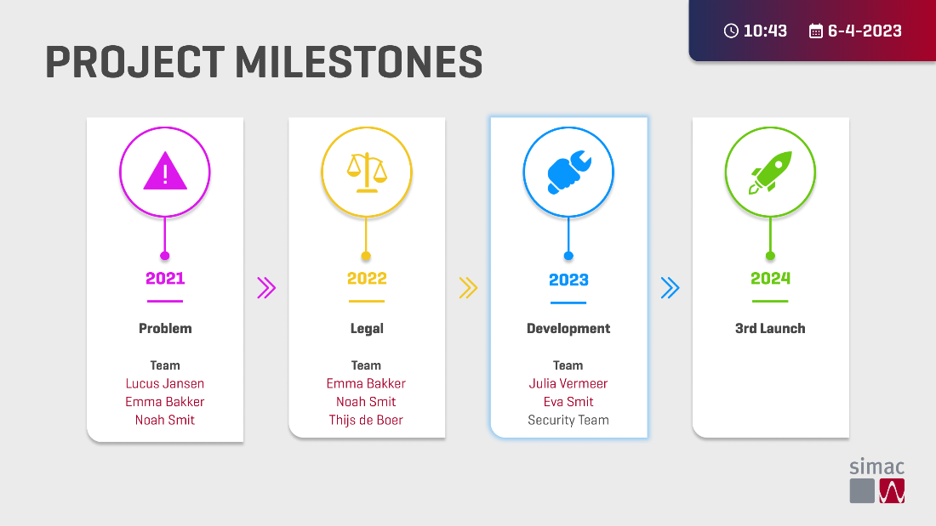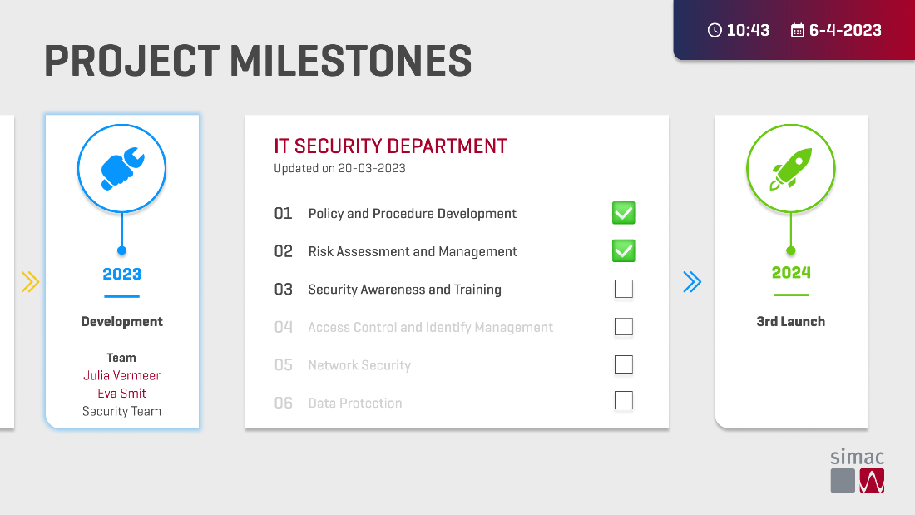

### On screen 1, what immediately draws your attention?

The icons, their colors and the huge titles

### On screen 2, what immediately draws your attention?

The icons, their colors and the huge titles

### Would you look at these screens if it was present at your work?

Yes, its minimalistic and it has huge icons

### On a scale from 1-10, how would you rate the design and layout of these screen 1?

8,it’s not obvious that the development is currently active in project. Rather make the panel bigger than just highlighting it

### On a scale from 1-10, how would you rate the design and layout of these screen 2?

8, make the current active team more obvious. The connection of the tasks and current active team are also not obvious, so make a more obvious connections of those

### On a scale from 1-10, how much do you think the content on screen 1 promotes a sense of recognition and appreciation?

7, recognition and appreciation are not obvious.

### On a scale from 1-10, how much do you think the content on screen 2 promotes a sense of recognition and appreciation?

7, recognition and appreciation are not obvious.

### If you could change anything for these screen 1, what would you change?

Make it more readable and the panels bigger. Make it more obvious what the current active team is.

### If you could change anything for these screen 2, what would you change?

Make the current active progress more obvious. The correlation of tasks and active progress are also not obvious, so make a more obvious connection of those

## Screen 5

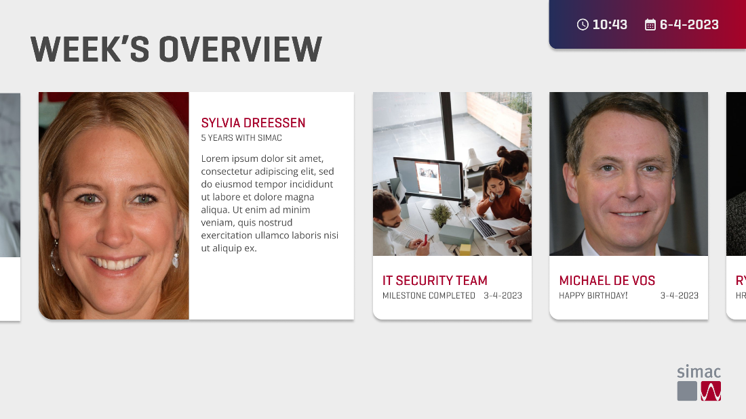

### On this screen, what immediately draws your attention?

The bigger photo on the left

### Would you look at the screen if it was present at your work?

Yes, if its about other students

### On a scale from 1-10, how would you rate the design and layout of this screen?

7.5, would make the images of the people stick out more. There’s a lot of text next to the images, so wouldn’t read all of it.

### Do you feel that the content on this screen fosters a sense of recognition?"

Yes, its like a slideshow of people so it does give sense of achievements of the people

### On a scale from 1-10, how much do you think the content on this screen promotes a sense of recognition and appreciation? If you could change anything for this screen, what would you change?

7.5,

Recognition part is okay, but for appreciation part. Want to see some trophies or highlight achievements of what they did (in a more graphical way). What’s the cool thing about it.

## General feedback

### Do you have any additional feedback or suggestions related to the screens or the overall testing experience?

### Based on your overall experience with the screens, what other types of content or features do you think could further enhance recognition and engagement at SIMAC?

# Conclusion

The screens could potentially help to stimulate sense of recognition and appreciation for the employees of SIMAC. Even though the screens do have something attention-grabbing like the big title and colors, most also have at least one part in the screens that has a lot going on, which could make people not pay a lot of attention to it or not look at all like the statistics screen. The feedback gathered from the user testing is:

* Explain information more graphically with icons or text.
* Make the connection between subjects more obvious
* Make the designs more minimalist